**Practice Problems - Sequential Circuit Analysis**

**Sequential Circuit Analysis**

**Question 1:** A sequential circuit has two flip-flops A and B, two inputs X and Y, and one output Z. The flip-flop input equations and output function are as follows:

SA = BX + B’Y’

RA = B’XY’

SB = A’X

RB = A + XY’

Z = AXY+BX’Y’

1. Draw the logic diagram of the circuit.
2. Derive the state table and state diagram of the circuit.

**Question 2:** For the sequential circuits given below

1. Write flip-flop input equations
2. Write output equation
3. Derive state table
4. Draw state diagram

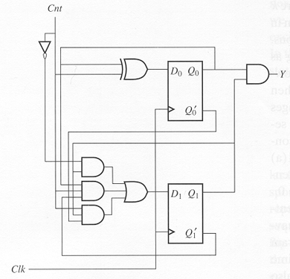

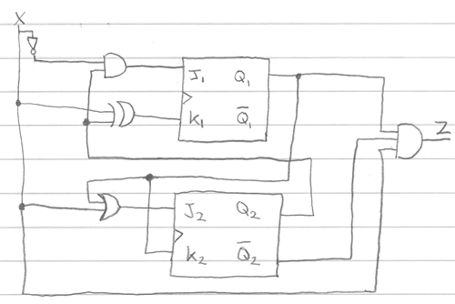

**Latches**

**Question:** Add control input in SR Latch given in figure 5-4 (Page 211 Moris Mano 4th Edition).

**Question:** A reset-dominate latch has a **set** (L) and a **reset** (M) input. It differs from a conventional SR latch in that, an attempt to simultaneously set and reset the latch (i.e., when L=1 and M=1) results in **setting** the latch so that it stores a 1. In a normal SR latch these would be forbidden inputs. SR latch is given below:

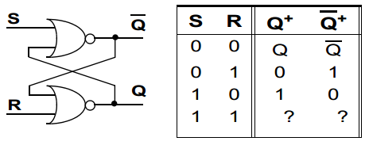

**(i)** Design an LM Latch.

**(ii)** Consider the sequence of values stored in the latch is 01100111. Give the L & M input pairs of signals for this sequence to be stored.

( , ) ( , ) ( , ) ( , ) ( , ) ( , ) ( , ) ( , )

You can safely assume that the latch was set initially before this sequence of storage.

**(Help:** You can use any concept which we have studied so far to design LM Latch).

**Question:**

**(a).** What should be the logical value of clock Pulse (CP) at the time of enabling the XY Latch whose diagram is shown below?

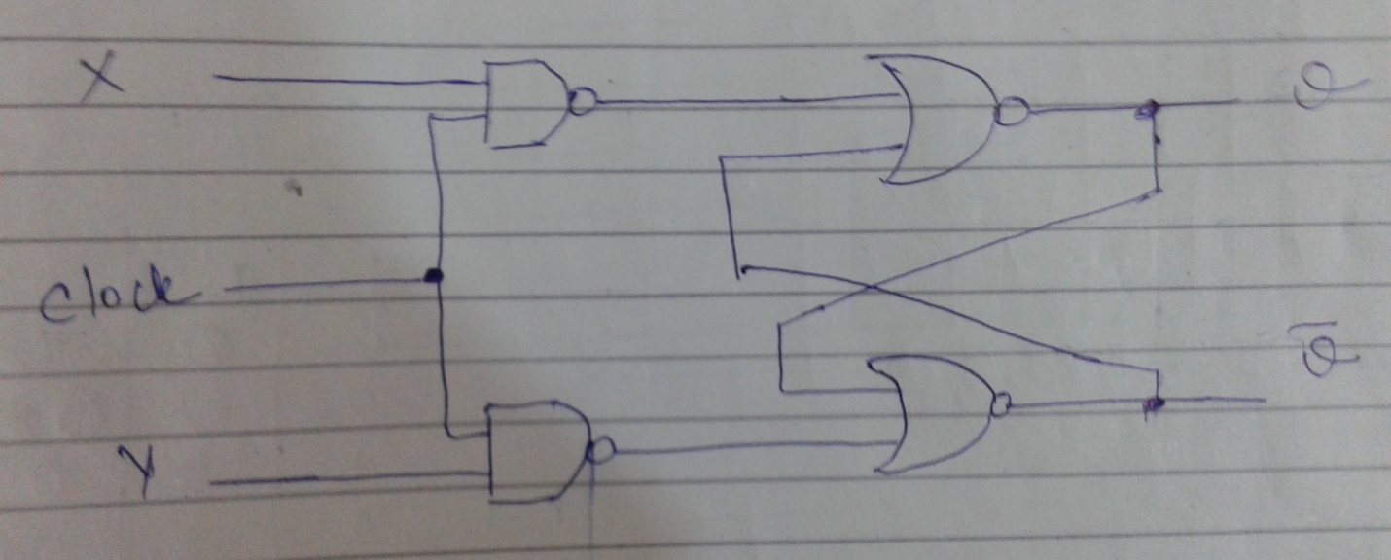

CP = _________

**(b)** Fill the function table for above latch.

|  |  |  |  |
| --- | --- | --- | --- |
| CP | X | Y | Q(t+1) |
|  |  |  |  |
|  |  |  |  |
|  |  |  |  |
|  |  |  |  |
|  |  |  |  |

**Flip-Flops**

**Question:** **(a)** Characteristic table of T (Toggle) Flip-Flop is given below, design the flip-flop:

|  |  |  |
| --- | --- | --- |
| **T** | **Q(t+1)** | **Operation** |
| 0 | Q(t) | No Change |
| 1 | Q’(t) | Complement |

**(b)** Design a T-R flip-flop with following characteristic equation; also make its characteristic table:

Q(t+1) = T’Q(t)+RT

**Book Exercises:**

5-6 to 5-11 (Excluding 5-3 and 5-9)